Day 2 #frontenddeveloperlove #frontendlove #FrontendDeveloperLover

Evan YOU – State of Vue

VUE.js most starred project on github in 2017
2016 7.6k
2018 83.8k

npm downloads
2016 0.21m
2018 9.72m

Vue.js DevTools Weekly Active Users
2018 355k

Minor 2.5 version
- improved typescript integration
- error handling
- functional component in single function component

New Releases
- eslint-plugin-vue 4.0
- test-utils
- vue-devtools 4.0 edit state in editor
- news.vuejs.org

Maturing ecosystem
- Nuxt reached 1.0
- Vuetify 1.0 one of the best component libraries
- NativeScript 1.0

Integrations:
- VSCode - Vue debug support
- CodeSandbox Vue SFC right in your browser good for prototyping
- „Prettier“ support for Vue SFC
- Ionic4

Vue-CLI
- Next generation of vue-cli
- vue-cli 3.0
- Goal: provide a way to get up and running with Vue

There are some problems that approach did not work on:
- templates are not upgradable
- template maintenance difficulty
- naked configuration are intimidating takes some webpack expertice
- forked templates need to consistently sync with upstream

POI is a great tool in Vue ecosystem

The new VueCli 3.0
vue create hello
vue serve App.vue
vue build App.vue will create a bundle
vue build –target wc // webcomponent
vue build –target wc-async „./folder&file“ creates a app that you can use in vue, react or javascript
Other Tools:
- e2e (with cypress)
- jest
- prettier
- eslint

subl . „start sublime with folder .“

What next?
- Better async error handling
- better warnings line numbers
- v-for-iterator support
- 2.6 Proxy-based reactivity system // means drop support for older browsers
- VUEX simpify API with async/ await

FAZIT:
Evan hat die Neuigkeiten in der neuen version kurz erzählt mit Focus auf vue-cli

ROMAN KUBA Scaling VUE in an existing stack

Why do you want to adopt it?
Adopting is an investment. It costs effort.

Competing Tech will run in parallel
Angular vs Vue // lots of discussions in team, where to draw the line.
A FULL SPA is problabyl not possible at all

Seine Firma: Cloudbees/Codeship

Earlier
- Stack dictated by jquery, then angular and coffeescript
- not alot of resouces
- larger amount of users per tech

Somethimes it feels like FrontendDevvs backend developers

“Lets take vue “ - “but there is react...”

What worked for him to migrate
SPLIT into phases
1. reduce as much as possible
- decide on one language js coffescript,
- remove unknowns

2
BETTER BUILD SYSTEM
- webpack is your fiend plays nice with vue
- VUE SFC single file component

FAZIT:
Talk war eher über generelle tipps für migration irgendwelche Phasen..

GUILLAUME CHAU - APOLLO, GRAPHQL AND VUE: the ultimate stack

GraphQL
- query language for the client to fetch data from the server
- community of tools
- based on typed schema

type message {

}

Strong typing:
- help prevent erros
- improve the debugging experience
- more explicit api (auto DOCS)

query:
{
messages {

}
]

query only the data you ndeed!
Reduce transfer size
no watterfall requests

Clear and simple structure

Evolve your API

Add new Fields

Who is using Graphgl:
- facebook
- twitter etc…

APOLLO
What is it?
Server tool that allows you to build graphql applications
(by the community for the community)

Apollo Server
- you can make several queries
- like mutations to change your data

resolvers allow you to make mysql requests

- Graphcool YOGA https://github.com/graphcool/graphql-yoga
- Apollo Launchpad prototype a graphQl schema in minutes
- (allows you to create a Apollo server)
- Apollo Engine -Monitoring with history, etc.,..

Schema Stitching is also possible
e.g. you have a weather schema an you can easily merge it with your app.

Apollo Client from Apollo-boost
https://www.apollographql.com/client/

Vue-apollo

DEMO
vue create vue-amsterdam
default
cd vue-amsteram
yarn add-D vue-cli-plugin-apollo
vue invoke apollo
add graphql API Server y
enable automatic mocking ye
add apollo enigne yes
api key // get one vor fore
yarn run graphql-api // starts server

yarn run serve

then in localhost:4000
{
hello(nane: „joe“)=
}

adds
graph filess .gql

in the type-defs.js he changed the queries
FAZIT:
War interessant mal was über GraphQL gehört zu haben und einen ungefähren Einblick zu erhalten

Alexandre Chopin - NUXT
NUXT.JS CO_Author

NUXT for serverside rendering

Dependencies

Vue
Vue-server-renderer
Vue-router
vue-meta
vuex

You need a router for ServerSideRendering!

Production modes available:

UNIVERSAL(if you need server) -
SPA -
GERERATD(gereneratees html static fiels

FAZIT:
- Interessante Technologie
- Die Leute die es benutzen waren begeistert.
- Leider war Vortrag nicht so gut. Er war verkatert und hat Sachen vergessen.
- Sodass der Vortrag zu früh fertig war, zum Glück Q&Q
- aber sehr interessante Technik

EDUARDO SAN MARTIN MOROTE STATE ANIMATIONS – Getting them right

- vuefire binding for firebase
- vuemotion - Easy and natural state transitions https://posva.net/vue-motion
- vuetweezing - Easy, customizable and automatic tweening nicely served in scoped slots https://posva.net/vue-tweezing

LIBRARIES:
- VueMotion
- VueTweezing
- tween.js
- p5

Demos:
https://bit.ly/posva-ams

Repository:
https://github.com/posva/state-animation-demos

Activity monitor

Animating when
user does something (hour glass) loading spinner
we need users attention
we want to make things fun
in vue

<transitions/>
and transition-groups

based on
v-if v-show key v-for

:key trick with route transitions
Clever trick to use :key binding to the full path to force transitions when router changes:
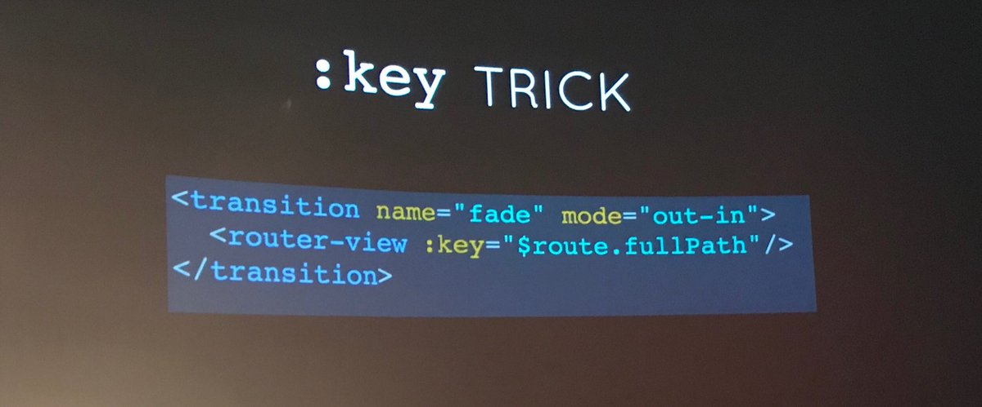

This is because Vue Router does not notice any change if the same component is being addressed. With the key, any change to the path will trigger a reload of the component with the new data.

What and for what:

bool – for toggling on/off class
basic transitions
good for opacity colors, etc.
bad for rotation, translation , scaling (unless linear easing)
you do it with computed values
easings - go from 10 to 100 bouncing in
- easing graph
-highly customizable
many existing easings
custom duration
easy to chaining
playback control
physics SPRING
go to 100 quickly and no oscillation
motion graph
FEEL NATURAL

how to create:
tween.js (but lot of code) https://createjs.com/tweenjs
https://github.com/sole/tween.js

that’s why
VUE-TWEEN https://github.com/chay22/vue-tween
Example: using scroll instead of time as input
VUE-TWEEZING
The Declarative with VUE-TWEEZING (Is less than 1KB)
https://github.com/posva/vue-tweezing

Declarative Tweening
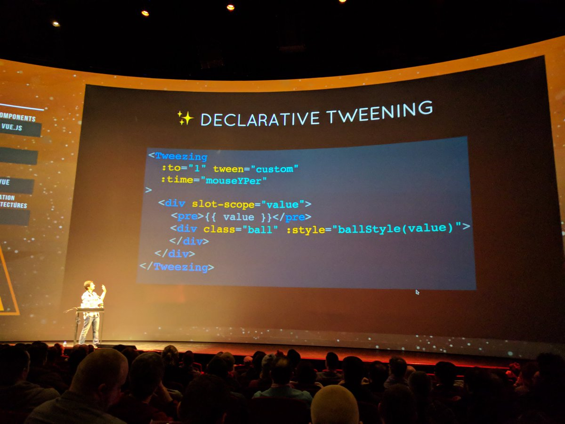

<Tweezing
:to=“stats“
:duration=“updateInterval“

TWEEN ENGINES
tweenjsHelper
vue-motion (https://github.com/posva/vue-motion)
(SPRINGS with VUEMOTION)
<MOTION :values=selecteValues“>
</Motion

vue-tweezing

BONUS
Animating sound

FAZIT:
- Sehr interessant!
- how to do Animations
- und zusätzlich noch experimentelle aber innovative Animationsmöglichkeiten
- z.b: Sound-Animieren
- oder man nimmt scroll-input als input für animationen (tweenings, etc,..)
- unterscheidet bool, easings, physics

Plamen Zdravkov - BUILDING REUSABLE UI COMPONENTS IN VUE
…and what they have learned working on Kendo UI

Types of Web UI Components
- simple UI components – inputs , buttons, animated div elemnts
- extendd UI componetns, - dopdown, pickers tabs, slides (with a bit more advanced js )
- super components – Dropdownlist with possible features , grid, scheduler,

Process of creation
- First you need a nice design
- Then you create html css renderings
- recognize small components and divide into these components
- expose properties and events so that it can communicate with environment
- templates
- keyboard support
- accessibility
- combine in one component

Source of Simpe Dropdown in Vue.js

DROPDOWNS UI design
you need to be able to add different html markup different dropdowns

SIMPLE EXAMPLE HOW YOU WOULD DO IT IN VU:JS

themebuilder.telerik.com/kendo-ui
telerik.com/kendo???

Fazit:
- hat die schritte erklärt wie sie die components entwickeln
- war ganz ok

EDD YREBURGH – UNIT TESTING VUE COMPONENTS

http://slides.com/eddyerburgh/testing-vue-components#/
Testing vue.js application: ctwvuejsamst18

Compilers:
- webpack (vue-loader)
- or jest(vue-jest)

JEST (http://vue-test-utils.vuejs.org/en/guides/testing-SFCs-with-jest.html)
Zero conf approach to testing

- install jest
npm install –save-dev jest vue-jest babel-jest

- in package.json
jest : {
transform : {
„^+//js ,
}

- npm run unit
- mount
vue-test-utils
// makes mount available
const wrapper = mount(modal)
Component contract
Agreement between component and rest of world that says: “when u give me this input I give you this output”

Type of INPUTs:
- user action
- props
- store you have to provide the store as input in order for the component to work

OUTPUT

He didn’t add tests for slot content (There is a better way for testing that)

html()toMatchSnapshot()

“Snapshot test” is a way of safeguarding of a components output

Does previous snapshot exist?
Yes – compare to previous snapshot
no – create snapshot succeed

It is basically a diff of markup

jest-serializer-vue for formatting markup…

overwrite snapshot
npm run unit -- -u
TEST SLOT CONTENT
At this moment we are rendering slot, but not testing…
Therefore:
slots : {
default:‘<p></p>’

https://vue-test-utils.vuejs.org

FAZIT:
- Unit testing mit dem SLOT content war ziemlich interessant und NEU
- Generell guter einblick in unit-testing mit vue.js

SEBASTIEN CHOPIN – HOW TO SERVER-RENDER

SERVER SIDE RENDERING‘
laravel php
ruby on rails
django
,…

browser goe to

Ives van Hoorne - VUE DEVELOPMENT IN CODESANDBOX

https://codesandbox.io/

Webbased Editor

Technology:
css sylus
vuetify
firebase
vetur
monaco-vue

FAZIT:
- Sehr beeindruckend was der Junge gemacht hat.
- Toller Vortrag.
- Interessantes Konzept →online webeditor für VUE, React, und andere Sprachen mit Github integration Syntax highlighting, live preview,… etc

SARAH DRASNER Serverless Functions and VUE.JS

https://css-tricks.com/exploring-data-with-serverless-and-vue-part-i/

“server management and capacity planning decisions are completely hidden from the developer or operator.”

“Serverless is the most clickbaity title for an actually interesting thing.“

Serverless: spend less time setting up and maintaining servers
+ you pay only for what you use usually a lot less
+ really really cheap
+ less time baybystitting
+ breaking things into small bits

Serverless all things? No!
- not good for long playing tasks, socket, multiplayer,..
+ good for:clean data on cron job

- take data and use it to create data
- free account signup
- Stripe checkout for monetization
- once u create stripe account verify your id
- what stripe exprects : express

https://jakearchibald.github.io/svgomg/

Fazit:
- Serverless entmystifiziert
- Zum glück eingegangen auf „clickbaity“ titel
- Könnte eventuell interesssant sein auch für privaten Gebrauch…
- weil billiger und keine server-wartung

